**Inception Phase Specification**

Team Added Value

CIS 310-01

**System Request**

A summary of the information system opportunity.

**Project Sponsor**:

* The project is being sponsored by Baylee Pulliam who handles communications and marketing for the University of Louisville Research and Innovation department

**Business Need**:

* Increase revenue
* Streamline the application process
* Engage students
* Making navigation easier

**Business Requirements**:

* Connect industry partners to research opportunities
* Connect researchers to funding
* Showcase achievements to the community via newsletters

**Business Value**:

* Increase in university revenue
* Each project will bring in upwards of 40% of the overall cost
* Increase in university’s overall academic image

**Special Issues or Constraints**:

* University of Louisville web design standards
* Keeping valuable website copy

UofL Research & Innovation Website Renovation

Vision (Small Project)

CIS 320-01

Version <3.0>

Revision History

|  |  |  |  |
| --- | --- | --- | --- |
| **Date** | **Version** | **Description** | **Author** |
| 27/Jan/20 | 1.0 | First Iteration | Ruomei Wang |
| 10/Feb/20 | 2.0 | Second Iteration | Sohal Patel |
| 1/Mar/20 | 3.0 | Inception Spec | Ruomei Wang |
|  |  |  |  |

Table of Contents

1. Introduction 6

1.1 References 6

2. Positioning 6

2.1 Problem Statement 6

2.2 Product Position Statement 7

3. Stakeholder and User Descriptions 7

3.1 Stakeholder Summary 7-8

3.2 User Summary 8

3.3 User Environment 8

3.4 Summary of Key Stakeholder or User Needs 9

3.5 Alternatives and Competition 9-11

4. Product Overview 11

4.1 Product Perspective 11

4.2 Assumptions and Dependencies 12-13

5. Product Features 13

6. Other Product Requirements 13-14

7. Process Models 15-16

8. System Requirements (User End) 17

9. List of Use Cases 17-19

10. Use Case Models 20-22

11. Initial Architecture Considerations 23-24

12. Risk Analysis 24-25

13. Team Charter 25-26

14. Gantt Chart 27-29

15. Inception Phase Prototype 30

Vision (Small Project)

# Introduction

This vision document is to collect, analyze and define high-needs and features of the University of Louisville Research and Innovation website renovation. The document focuses on the capabilities needed by the stakeholders and the target users, and the improvements provided by the renovation.

## References

1. Ambler, Scott W, and Matthew Holitza. “*Agile For Dummies®, IBM Limited Edition*.” Print.

2012.

2. Dennis, Alan, et al. *Systems Analysis and Design with UML, 4th Edition*. John Wiley & Sons,

2012.

3. *Front Page - Research and Innovation*, University of Louisville, louisville.edu/research.

# Positioning

## Problem Statement

|  |  |
| --- | --- |
| The problem of | The UofL Research and Innovation webpage being difficult to navigate |
| affects | UofL students and faculty, researchers, industry |
| the impact of which is | Results in less researchers, students, and organizations involved in this program, and in the end affects the revenue of UofL research office |
| a successful solution would be | Renovate the website menu and layout |

## Product Position Statement

|  |  |
| --- | --- |
| For | UofL Research Center |
| Who | Needs more revenue to fund research |
| The (product name) | A website |
| That | Attracts more industry and conducts further research |
| Unlike | Other research instructions and facilities |
| Our product | Clear layout and navigation for target customers |

# 

# Stakeholder and User Descriptions

A stakeholder is anyone who impacts or is impacted by an organization's actions or products.

## Stakeholder Summary

|  |  |  |
| --- | --- | --- |
| **Name** | **Description** | **Responsibilities** |
| Louisville community | Residents of Louisville who want success for our University | Residents of Louisville can promote our University’s research and innovation |
| University of Louisville employees | UofL employees who wants to see our University thrive on research | UofL employees can work more efficiently and effectively to help approve findings and monitor research progress |
| Louisville Metro Government | Louisville government that helps UofL become a better University | Louisville government can maintain a safer environment for UofL students and researchers |

## User Summary

|  |  |  |
| --- | --- | --- |
| **Name** | **Description** | **Responsibilities** |
| Students | UofL students who wants to participate in research | Engage in learning and participate in research actively |
| Researchers | UofL researchers who want to innovate and discover new things | Lead students to rewarding and meaningful research, and provide the industry better solutions |
| Industry | Industry that needs technology solutions and advanced knowledge | Reach out to our University and help conduct the solutions given by the researchers |

## User Environment

1. Students: Students need to have the information available to make an educated decision about their choices for attending a university. The prospective student needs to be able find information on degrees offered, tuition and costs, the admissions and application process, admission requirements, and deadlines for admissions and registration. Many students also need to know about scholarships, housing, and student aid.

It is not easy to see the research area, latest available opportunities, latest news, admission requirements and procedures. This information will affect number of students who apply and join the program.

1. Researchers: It is not easy to find all the research activities like meeting dates, new projects, and resources. This causes delays in producing research and affects the number of projects the university undertakes.
2. Industry: Universities depends on donations and endowment for many of their operations regarding to the institution. Not having enough university industry collaborations affects the university.

## Summary of Key Stakeholder or User Needs

|  |  |  |  |  |  |
| --- | --- | --- | --- | --- | --- |
| **Need** | **Priority** | **Concerns** | **Current Solution** | **Proposed Solutions** | |
| Getting more funding for UofL research | High | UofL research website is not intuitive enough to help users navigate information | Renovate the menu and layout.  Addition of some internal hosted modules to virtual assistance or explanation in for of animation, video or multimedia modules. | | Overhaul the website to make it more intuitive, create better design and helpful for researcher and learners to obtain meaningful material. |

## Alternatives and Competition

|  |  |  |
| --- | --- | --- |
| **Institution Name** | **Strengths** | **Weaknesses** |
| University of Kentucky | * Clear display of achievement and breakthroughs * Event Announcements on main page * Request for Visit Application integration | * Lack of an intuitive navigation menu * Hard to find funding information * No landing initializing on click on any mentioned menu |
| Indiana University Bloomington | * Great website design * Good narratives about research achievements * Research Page is very helpful and link regarding to requirements | * Lack of an intuitive navigation menu * Body content is not attractive for a user to stay and read full page * Some buttons could be confusing * Hard to find funding information * Footer menu Color Combination is not making attractive or not looking as its part of website |
| Ohio State University | * Dedicated section for research news * Main Menu Management | * Website is too simple, not substantial or concrete enough * Hard to find funding information * Website is not optimized * No contact US form Integration for direct email or message sending to the admin * No proper menu button in Contact US section for asking question, information Section, Virtual tour and Coming up. |
| Yale University | * Great website design * Clear separation for different users between researchers and industry * Proper Admission Guideline and requirement * Searching by keyword | * No dedicated entrance button for students * Hard to find funding information * Header color is emerged not so well to describe a header * Copyright footer space Between typography and lower line * Color Combinations of Footer and whole website is not so well. * Contact US form not Integrated for Direct message of Direct email from same page * Student Section Domain is separate |

# Product Overview

## Product Perspective

In order to simplify the process of grant application, each step for researchers, students and industries will be revised as depicted in the To-Be Model (Figure 1). The process will be more centralized and organized.

Figure 1 – To-Be Model

## Assumptions and Dependencies

1. The default language will be English. It is assumed that users who cannot speak and write in English will also change language with built in function of our website to change desired language.
2. When using the search feature, it is assumed that users are literate, also able to identify actually what he or she is looking forward on this platform.
3. It is the basic requirement to have website address and a working network on any machine with web browser to access website.

# Product Features

1. Intuitive and Responsive Navigation Menu
2. User Friendly GUI Design
3. Separation of Resources for Different User Groups
4. Updates About Recent News and Latest Researcher Meetings and Conferences News
5. Announcement Regarding to New Research Program
6. Newsletter Subscription Through Email
7. Admission Requirements and Procedure
8. Integration of Fund Transfer Protocols
9. Dedicated section of Funding Information

# Other Product Requirements

1. Academic:

* Provide More Resources to Students: By striking up corporate partnerships, universities have more resources to undertake research, and they’re able to diversify their research areas.
* Moving in the Market: Universities know that some problems can’t be solved in isolation in a lab, and industry feedback is key to taking an invention or product from conception to market.
* Expose Students to the Industry Culture: Companies are hungry for ideas, and the actual technologies and intellectual properties to commercialize those ideas. And, companies are hungry for talent. This is a very good opportunity to expose students to the industry culture. When students graduate, they are better prepared to start working at these companies.
* The benefits for companies continue to stack up, including access to a network of faculty, key opinion leaders, and lead scientists, and the ability to team up with other companies interested in the same research.

1. Organizational:

To measure how well the system ultimately will be accepted by its users and incorporated into the ongoing operations of the organization, there are many organizational factors that can have an effect on the project, and developers know that organizational feasibility can be the most difficult feasibility dimension to assess. In essence, an organizational feasibility analysis attempts to answer the question – If we build it, will they come?

* Project Champion(s)
  + A champion: Initiates the project, promotes the project, allocates his or her time to project, and provides resources.
* Organizational Managers
  + Know about the project, budget enough money for the project, encourage users to accept and use the system.
* Users
  + Make decisions that influence the project, perform hands-on activities for the project, and ultimately determine whether the project is successful by using or not using the system.

# Process Models

To enhance the function and efficiency of the website, we need to simplify the process for users. In order to simplify the process of grant application, each step for researchers, students and industries will be revised as depicted in the To-Be Model (Figure 3). The process will be more centralized and organized in comparison to the As-Is Model (Figure 2).

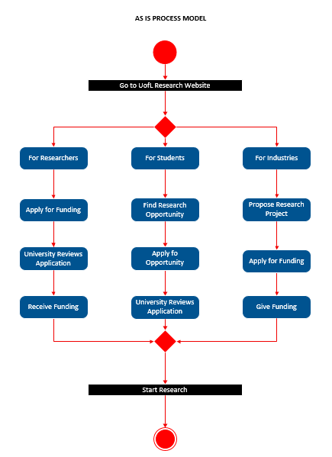As-Is Process Model

Figure 2 – As-Is Process Model

To-Be Process Model

Figure 3 - To-Be Process Model

# System Requirements (User End)

* On the user’s end, there are non-functional requirements.

1. OS: Windows 7, 8 & 10, Linux 2005 Minimum, MAC OS 10.0
2. CPU: Intel or AMD processor with 64-bit support; Recommended: 2.8 GHz or faster processor
3. GPU: NVidia GeForce GTX 1050 or equivalent.

Recommended: NVidia GeForce GTX 1660 or Quadra T1000

1. Disk Storage: 4 GB of free disk space
2. Internet: Internet connection required for software activation

# List of Use Cases

* An overview of essential use cases describing a specific situation in which a product or service could potentially be used.

|  |  |  |  |
| --- | --- | --- | --- |
| **Use Case ID** | **Case name** | **Primary Actor** | **Description** |
| UC 1 | Grant application | Researchers | Students will be able to apply for grant application and the system will accept it from them |
| UC2 | Update information on current partnerships | Admin | The admin will update information on current partnerships on the website |
| UC 3 | Allow weekly updates to newsletter | Admin | The admin will allow weekly updates to newsletter on the website |
| UC 4 | Allow to edit the newsletter | Admin | The system will allow users to edit the newsletter on the website |
| UC 5 | Delete newsletter | Admin | The system will allow administrators to delete a newsletter |
| UC 6 | Find information | Student | The system will have a search bar to help users find information |
| UC 7 | Target industry partners | Researcher | The system will target industry partners |
| UC 8 | Allow the modification of grants | Admin | The system will allow the modification of grants |
| UC 9 | Deletion of grants | Researcher | The system will allow the deletion of grants |
| UC 10 | Accept application | Student | The system will accept student applications |
| UC 11 | Edit Application | Student | The system will allow student applications to be edited |
| UC 12 | Deletion of student applications | Student | The system will allow the deletion of student applications |
| UC 13 | Funding Applications | Researcher | The system will accept researcher funding applications |
| UC 14 | Edit researcher funding applications | Researcher | The system will allow researcher funding applications to be edited |
| UC 15 | Delete researcher funding applications | Researcher | The system will allow the deletion of researcher funding applications |
| UC 16 | Take in industry proposals | Industry | The system will accept industry proposals |
| UC 17 | Editi industry proposals | Industry | The system will allow industry proposals to be edited |
| UC 18 | Delete industry proposals | Industry | The system will allow the deletion of industry proposals |
| UC 19 | Add and conduct surveys | Student | The system will store and allow the surveys |
| UC 20 | Modify the surveys | Admin | The system will allow modifications of the surveys |
| UC 21 | Delete the surveys | Admin | The system will allow deletion of the surveys |
| UC 22 | Login | Student | The system will allow users to login using their account names and passwords |
| UC 23 | Backup the data | Admin | The system will back up the data created |
| UC 24 | Recover the data | Admin | The system will allow the recovery of data when needed |
| UC 25 | Create profiles | Researcher | The system will allow researchers to create profiles to showcase their works |
| UC 26 | Add events | Admin | The system will allow admin to add events |
| UC 27 | Modify events | Admin | The system will allow admin to modify events |
| UC 28 | Delete events | Admin | The system will allow admin to delete events |
| UC 29 | Link the donation process directly to UofL development departments | Industry | The system will lead industries to UofL development departments’ webpages to continue their donation process |
| UC 30 | Link ThinkIR to the research page | Industry | The system will lead industries to UofL ThinkIR in order to showcase UofL breakthroughs |

# Use Case Models

* Models of how different types of users interact with the system to solve a problem. They describe the goals of the users, the interactions between the users and the system, and the required behavior of the system in satisfying these goals.

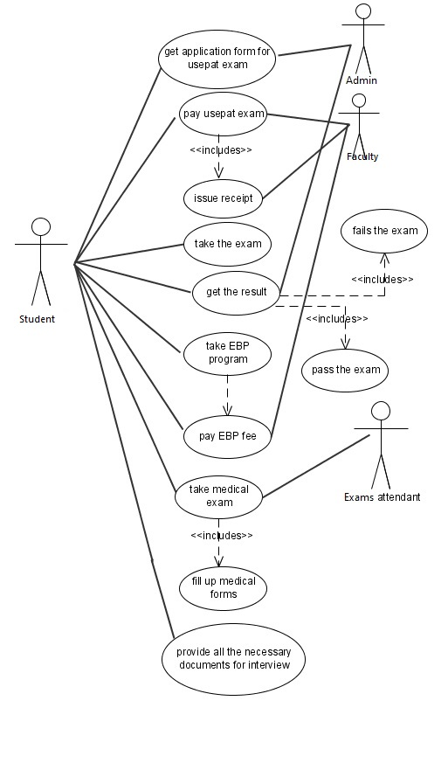

Figure 4 - Use Case for Students

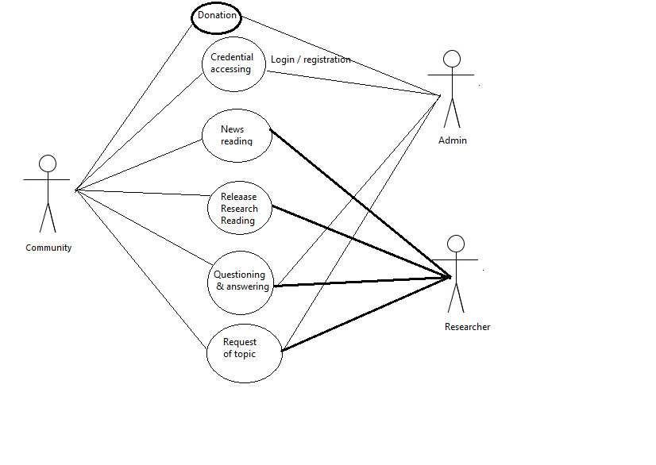

Figure 5 - Use Case for Community, Admin and Researcher

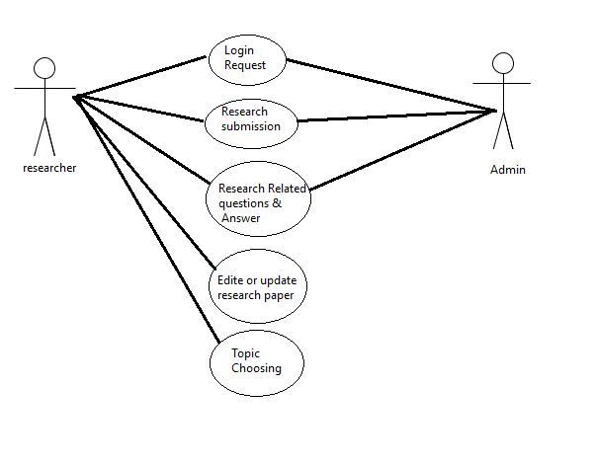

Figure 6 - Use Case for Researcher and Admin

# Initial Architecture Considerations

* Descriptions and representations of system architecture options from the design viewpoint and the realization viewpoint.

**1. Who Are Your Users?**

Without developing an understanding of who your users are and what they're coming to your website to seek out, you won’t stand much an opportunity when it involves organizing your information during a way that produces sense to them. Identify what your audience needs from your website and make that sure you place pages during a location that indicates their priority and relevance.

How do users currently navigate your website?

**2. Avoid Choice Overload**

Try to limit the amount of options you present to your users. Too many choices can cause users to feel overwhelmed. there's no have to list every single webpage in your navigation, and of course, that may do way more harm than good. Instead, put intuitive categorization to figure, placing important content in either the most or sub-navigation. Then, lead users to less-important pages through a logical internal link structure.

**3. Limit the number of Content on Each Page**

Avoid creating content that's long and cumbersome. Users that encounter lengthy content are likely to breeze by it without giving it any consideration. If you'll be able to limit the information presented to a user, not only is it more likely that they're going to actually read and have interaction with it, but it’s also more likely they're going to continue on their path through your website instead of bouncing far from it out of frustration.

**4. Limit Homepage Content**

The same is true when it involves the number of contents you ought to display on the homepage. Though it's always good to reference your most high priority and relevant content right the homepage, it’s important to be a touch exclusive in determining what that content are going to be, reserving valuable homepage land for less than truly valuable content.

**5. Label Logically**

When it involves naming the assorted categories to be featured in your website’s navigation, it's important to be clear and concise. Strike a balance between incorporating keywords that are important to go looking engines and keywords that are descriptive and concise enough for users.

# Risk Analysis

* Risk analysis is the process of identifying and analyzing potential issues that could negatively impact key business initiatives or critical projects in order to help organizations avoid or mitigate those risks.

**Risk #1**:

* The website’s design does not meet UofL Research and Innovation Office’s expectations.
* Likelihood of Risk: Low Probability of Risk
* Potential Impact on the Project: The risk likely will decrease the website’s effectiveness in attracting funding and showcasing UofL research breakthroughs. The project will be slowed.
* Solution: The development team needs to meet with Research and Innovation department regularly to ensure the project quality. It is important that the website design and layout get tested before it launches and serves the public.

**Risk #2**:

* The team members have not been acquainted with WordPress prior to this project.
* Likelihood of risk: High Probability of Risk
* Potential Impact on the Project: The risk may increase the time to complete the design tasks by 50%.
* Solution: Adequate training will reduce the obstacles of not being familiar with WordPress. Additionally, outside resources and materials on WordPress should be brought in for at least some part of the early programming tasks.

**Risk #3**:

* The design of the website did not reinforce the security and privacy protection aspect.
* Likelihood of Risk: Low Probability of Risk
* Potential Impact on the Project: The risk will decrease the quality of the project outcome, and potentially lead to data breaches and hacker attacks.
* Solution: Team members should put security measures in place when designing the website to avoid leaks, hacks and breaches. The project team should conform to UofL Information Security Office’s ISO PS001 Information Security Responsibility

policy.

**Risk #4**:

* The website does not work on all kinds of web browsers.
* Likelihood of Risk: High Probability of Risk
* Potentially Impact of the Project: The risk will decrease the effectiveness of the project outcome, and lead to longer revision time.
* Solution: The project team needs to test the prototype on multiple browsers and platforms before launching the website officially. Members should check the site under different configurations to avoid the risk.

# Team Charter

* The Added Value group is committed to operating as a team. We will conduct our activities as a unit in a handful of keyways. We have established a multitude of team goals and communication standards.

**- Team Goals**

We want to accomplish all our assignments on time. This doesn’t simply mean turning in documents before a deadline. This means that we will agree upon a review deadline so we can ensure the integrity and quality of every component. We want to have successful presentations. This means that we want to be prepared and have practiced our sections individually and as a group. We want to communicate well as a team. Any issues or inquiries should always be resolved or answered in a timely manner. We want to improve our overall understanding of systems analysis. This means attending class sessions to take in valuable information not offered by the text. Most importantly, we want to function well as a team and contribute equally.

**Group Meetings**

Group meetings are imperative to our success. We will discuss our progress in class and deliberate on whether we need to meet. We’ll decide when to schedule meetings together based on times that work for everyone. We’ll send the meeting date and time in our GroupMe chat.

**Team Communications**

We will communicate ideas in person and through written word. We have set up a Microsoft Teams group and will be creating Google Docs to live share and edit. We will be communicating with the client and posting her answers to the class blackboard discussion board. We will communicate with the instructor in person, through email, and during office hours if necessary.

**Team Decisions**

We will strive for healthy communication as a group. If a consensus cannot be made naturally, it’s only fair to hold a vote. If a tie were to occur, we would have to debate once more.

**Team Repositories**

We will be sending files within the Microsoft Team group, in a Google Drive, and GroupMe if necessary. We will be taking notes individually on paper/on our laptops. We will compare them as necessary.

# Gantt Chart

* A screen shot of a cage

  Description automatically generatedA Gantt chart is a type of bar chart that illustrates a project schedule. This chart lists the tasks to be performed on the vertical axis, and time intervals on the horizontal axis. The width of the horizontal bars in the graph shows the duration of each activity.

Figure 7 - Gantt Chart Part 1

Figure 8 - Gantt Chart Part 2

Figure 9 - Gantt Chart Part 3

# Inception Phase Prototype

For our prototype, we have focused on making it easily navigable for students, researchers, and industry partners. We have these three categories of our primary users on the top of the page to click on. This will lead them to a page specified just for them and have all the information needed to look for funding, grants, applications, and other important resources. These three are the highest risk cases as funding from the industry will increase revenue for UofL. With a simplistic layout, and our news and events being shown easily accessible as well, this layout makes our website a viable way for UofL to get more grants and, therefore, more money.

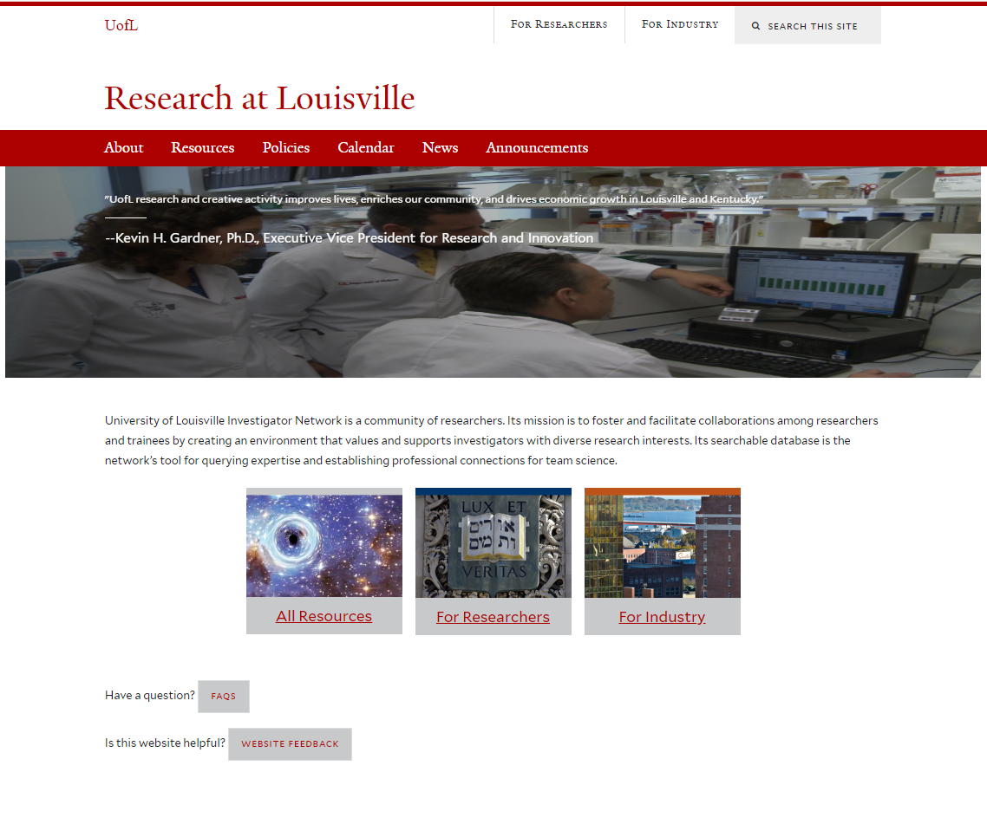

Prototype Link:<http://pictureintext.net/pro/Demo1/index.html>